HUM 2220 Ancient Site Historical Preservation Project
Historic and Cultural Preservation/Conservation Grant Application

Name
Professor
Institution
Date

Every year around the world, millions of people visit museums, historic cities, and ancient sites to make contact with the past. This vast interest in our cultural heritage reflects the desire of people everywhere to know about and understand human origins and achievements.
Neville Agnew, Associate Director for Programs, Getty Conservation Institute

...To save the places where history happened. National Trust for Historic Preservation

This grant is intended to fund projects that will preserve and promote the world's historical and archaeological heritage for future generations because our historical heritage is a universal legacy. Award of this grant will fund your archaeological and historical preservation project up to $10,000. In order to be considered, your site must be designated a historically or archaeologically valuable site (i.e. UNESCO World Heritage Sites).
Directions for Completing the Historic Preservation Grant Application (in the following order):
A. Complete the GRANT APPLICATION COVER SHEET
B. Write an EXECUTIVE SUMMARY OF THE PROJECT, ITS PURPOSE, AND OUTCOMES
C. Establish the LEGAL JURISDICTION OF HISTORICAL SITE
D. Provide BACKGROUND INFORMATION AND DESCRIPTION OF THE HISTORICAL SITE
E. Describe the HISTORICAL SIGNIFICANCE OF THE SITE
F. Provide DOCUMENTATION, INCLUDING PICTURES AND MAP, OF SITE

Note to Applicants: Grant Application Format Outline
In order to be considered for funding, (in other words, a passing grade!) the application must be complete. Use the following checklist to ensure your application includes the following items in the order indicated:

A. Grant Application Cover Sheet _____
B. Executive Summary of the Project _____
C. Legal Jurisdiction _____
D. Background Information and Description of the Historical Site _____
E. Historical Significance of the Site _____
F. Documentation _____

For further guidance, see the Grant Assessment Rubric online on Canvas, view this article, from the Getty Conservation Institute, and refer to the UNESCO World Heritage sites list.
http://www.getty.edu/conservation/publications_resources/newsletters/12_2/feature1.html
http://whc.unesco.org/en/list/
Credits:
World Monuments Fund, watch@wmf.org.
National Register, Florida Division of Historical Resources - http://www.flheritage.com/preservation/nr/nomination.cfm
Grant Makers of Western Pennsylvania, Common Grant Application Form - http://www.gwpa.org/s_gwp/bin.asp?CID=4684&DID=45895&DOC=FILE.PDF

A. Historic Preservation Grant Application Cover Sheet
Legal Name of Organization _____________________________________________________________
Titles and Printed Full Names of Members of Organization
_____________________________________________________________________________________
_____________________________________________________________________________________
_____________________________________________________________________________________
_____________________________________________________________________________________
_____________________________________________________________________________________
Street Address ________________________________________________________________________
City_________________________________________ State _____ Zip __________
Phone: _______________________________ OR E-Mail _____________________________________
Website (if applicable) _________________________________________________________________
Project Name _________________________________________________________________________
Purpose of Grant ______________________________________________________________________
Amount Requested: $ ____________________________ Total Project Cost: $ _____________________
Specific Project Goals __________________________________________________________________
_____________________________________________________________________________________
I CERTIFY, TO THE BEST OF MY KNOWLEDGE, THAT:
1) All information contained within this application is accurate,
2) This Organization does not support any political parties or political agenda, or engage in any terrorist activity, and
3) If a grant is awarded to this Organization, the proceeds of that grant will not be used for any unlawful purposes.
Signatures of All Members of Organization Date
_____________________________________________________________________________________
_____________________________________________________________________________________
_____________________________________________________________________________________
_____________________________________________________________________________________
_____________________________________________________________________________________
B. EXECUTIVE SUMMARY OF THE PROJECT, ITS PURPOSE, AND OUTCOMES
Write a narrative that follows the outline below. So long as the narrative flows in the designated order, feel free to include information that you believe is important to make your case. If a question is not applicable, explain. If a problem exists that might detract from the credibility of your organization or project, address it briefly; do not avoid or dismiss it. Be thorough yet strive for brevity and clarity. More is not necessarily better. Format according to the course standard essay guidelines (See Instructions for Essays on Canvas). Attach document as Part B Executive Summary of the Project.
- Brief description of the project (Identify type of project – conservation, preservation, etc.)
Having been given a chance a talk about historic and preservation areas, I gladly choose to talk about the Dallas Zoo. People from different parts of the country come to visit the Dallas Zoo because it is home to reticulated giraffes, there are also nearly two-dozen birds, fascinating reptiles, porcupines, flamingoes, tortoises, and many others. The zoo is also a place where zoologists can study about the mentioned wild animals and getaway places for families and people on holiday because it provides very ambient environments. The Dallas Zoo is 106 acres and it is 3 miles south of downtown Dallas, Texas. It is part of Marsalis Park .
- Problem and Need. Identify the problem to be addressed and the needs to be met by the project. What unique benefit(s) would the public be deprived of if you do not undertake this project? Provide and cite supporting data.
One of the biggest challenges in the Dallas Zoo is the extinction of other animal/bird species. The other challenge is dangers posed by some other animals where the fencing and cages are not sufficient to protect those watching animals from being harmed. The zoo is also detrimental to animal health and the care offered in the zoo is not sufficient for the animals.
- Outcomes. What goals and outcomes do you plan to achieve? Who does this project serve, and why is that important?
There are a number of goals that I aim to achieve. The first one is ensuring that the animals in the zoo like the giraffes, some bird species, and even porcupines are safe and have sufficient food. The next thing is to ensure that people coming to watch the animals enjoy and pay monies that are commensurate to the pleasure they get from viewing the animals. The project is also important to the zoologists especially those studying about animal extinction and thus supporting conditions should be put in place for them to study. The project is also important because it not only promotes local tourism but also international tourism. It is also a very important place for locals to relax during holidays and weekends which is it should be conserved.
- Why your organization should receive the funds to implement the project and how the funds will be spent.
My organization has been in the fore front in ensuring that conservation efforts are put not only on our natural resources but also those that are manmade like art centers. Often times, we fall short of cash due to unlimited wants in the conservation sector where for example the Dallas Zoo is one of the projects that our organization is unable to fund. For this reasons, therefore, we believe that once we are fully funded, we will undertake the activities of the Dallas Zoo project and ensure that it is cleaned regularly, animals are protected, and fences and cages are erected for animals that are now almost becoming extinct.
- Sustainability. Specify your long-term plans for the project after the grant expires. Remember to be realistic – long term plans may last 6 weeks, 6 months, or 6 years, or more. List other resources or strategies that you could develop that are still related to the original project (i.e. if you’re erecting a fence or barrier, a long-term strategy might call for including the means to maintain that barrier for an additional year).
We want to be very categorical that we will not abandon the project in the long term. We will liaise with government’s ministry of natural resources to ensure that the project does not get stuck. Our members will be among the tour guides who will get paid a fraction of tourists pay to sustain works such as cleanliness and maintenance of cages, fences, and security of animals.

C. LEGAL JURISDICTION / OWNER(S)
1. Government agency, public or private organization, or private individual(s) with legal ownership of the property.
Name of Institution/Organization or Individual Owner _______________________________________
____________________________________________________________________________________
Institution/Organization website _________________________________________________________
Telephone Number ___________________________E-mail___________________________________
Street Address________________________________________________________________________
City____________________________State/Province ____________________ Postal Code__________
Country_____________________________________________________________________________
2. Government agency, public or private organization, or private individual(s) with legal authority to make decisions about and/or approve or administer activities at the site. Check if same as owner ______
Name of Authorized Institution/Organization or Individual ____________________________________
Institution/Organization website __________________________________________________________
Telephone Number ___________________________ E-mail ___________________________________
Street Address________________________________________________________________________
City____________________________State/Province____________________ Postal Code___________
Country _____________________________________________________________________________
Does the owner of the property support the project? Yes ____No____ Don’t Know____

D. BACKGROUND INFORMATION AND DESCRIPTION OF HISORICAL SITE
1. Site Location and Coordinates
Site Name (s) ___Dallas Zoo___________________________________
Street Address_____650 S R L Thornton Fwy, Dallas, TX 75203, United States______________________
City/Municipality ____________Dallas _____________________________________
Region/Province/State___Texas __________________________________________________________
Postal Code ____________ Country________U.S.A__________________________________
Site Website____https://www.dallaszoo.com/explore-the-zoo/encounters-experiences/
Latitude/Longitude in decimal degrees ___Dallas Zoo__32.7405° N, 96.8162° W______________
(e.g. 95 Madison Avenue NY, NY, USA is 40.744200, -73.985300. There are websites that can assist in determining latitude/longitude, such as Google Maps.)
2. Type of Property: Original Use (select all that apply)
____ Archaeological or Historic Site ____ Residential Building ____ Civic/ Public Building
____ Commercial Building ____ Military ____ Cultural Landscape
____ Religious/Sacred Site/Building ____ Garden/Park ____ Townscape or Historic Center
____ Other (Describe) _________________________________________________________________
3. Type of Property: Current Use (select all that apply)
____ Archaeological or Historic Site ____ Residential Building ____ Civic/ Public Building
____ Commercial Building ____ Military ____ Cultural Landscape
____ Religious/Sacred Site/Building ____ Garden/Park ____ Townscape or Historic Center
____ Other (Describe) _________________________________________________________________
4. Site Description
Provide a brief description of the physical features of the site. This description should also include information about the site context (e.g. a rural valley, an urban setting, etc). (50 word limit).
Inside the park, there are trees and fencings with wire mesh and timber. Wild animals like are in cages while others can be viewed from outside. A few valleys water bodies (manmade lakes) and swamps. Other notable physical features are huge gates at the entry points and dug trenches for animals.
5. Physical Description
A. Provide a brief description of the physical construction and materials of the site, including basic design and general condition at present time (50 word limit).
The zoo is built with wire mesh and timber to shield people away from animals like giraffe. People from outside the fenced quarters can see the animals and those who can give giraffes what they eat they can do so. For birds, there are erected stands where they can stand aloft so that they can be viewed. _________________________________________________________________________________
_____________________________________________________________________________________
_____________________________________________________________________________________
B. Primary Construction Materials (select all that apply):
____ Timber ____ Fired Brick ____ Stone ____ Concrete _____ Metal
____ Earth (adobe, wattle & daub, pisé, etc.) ____ Other (describe)_________________________
The zoo is built with timber and wire mesh
6. Site Designations
UNESCO World Heritage Site? Yes____ No ____ Year of Inscription__________
Within a UNESCO World Heritage City or larger site? Yes ____ No ____ Year of Inscription_______
UNESCO World Heritage Tentative List? Yes ____ No ____ Year of Tentative Listing_____
UNESCO World Heritage in Danger? Yes ____ No ____
National Historic Landmark/Site designation? Yes ____ No ____ Year of Designation__________
Regional, state, or local Historic Landmark/Site designation? Yes __ No __ Year of Designation___1986____
Other designation(s)____________________________________________________________________
7. Threats, Dangers, and / or Challenges to the Site and Grant Project
Briefly describe potential threats, dangers, and / or challenges to the site and your project. These might include, but are not limited to: deterioration of the site, natural events such as hurricanes or earthquakes, multiple stakeholders with conflicting designs for or interpretations of the site, disagreement surrounding ownership/ authority over the site, legal borders, war or political conflict in the area, etc. (100 word limit)
The Dallas Zoo in 2018 was named among the 10 worst zoos for captured elephants. This is because the zoo has not been taking effective care of elephants and has led to deaths of many of them. The Dallas Zoo, mentioned alongside the Caldwell Zoo, are said to abuse elephants as property in their incessant pursuit of profits. In this respect, the capture of elephants from Swaziland caused a lot of outcry and put the name of the zoo in a bad shape. Another threat is during this pandemic where there is no cap on the number of people entering the zoo meaning those entering are at a risk of contracting covid-19.
E. HISTORICAL AND CULTURAL SIGNIFICANCE OF SITE
1. Site Significance
In a formal narrative, argue for the historical and cultural significance of this ancient site. Think of this essay as your opportunity to make the strongest case for why your site is so important that it deserves to be preserved and studied. What could it mean to us today and what can we learn from it? Think about how you believe this site reflects the historical period in which it was constructed and the cultural values of the civilization which built it.
There is no doubt that the historical significance of the Dallas Zoo is imbedded in the animals that they have reared over the years. Young children who visit the zoo only see those animals there. The other significant is ensuring that these animals do not get extinct since most of them are either being hunted or others are disappearing due to reduced reproduction. Thus, the conservancy is important historically because it preserves indigenous animals but also it is creates employments and earns government revenue.
2. Is the site currently used for religious practice or sacred ceremonies? Yes ____ No ____
F. DOCUMENTATION
____ Current Photos of Site (at least two required)
____ Most Recent Images or Photos of Site’s Defined Problem or Need
____ Photos or Images of Proposed Project Solution
____ Historical Images or Photos (if available)
____ General and Specific Location Maps (at least two required)
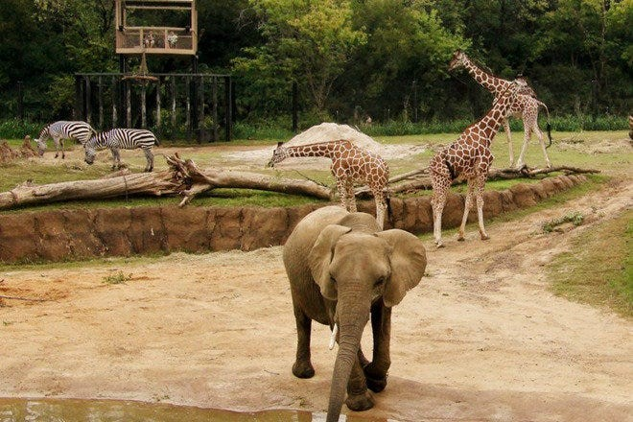

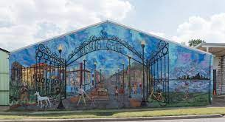

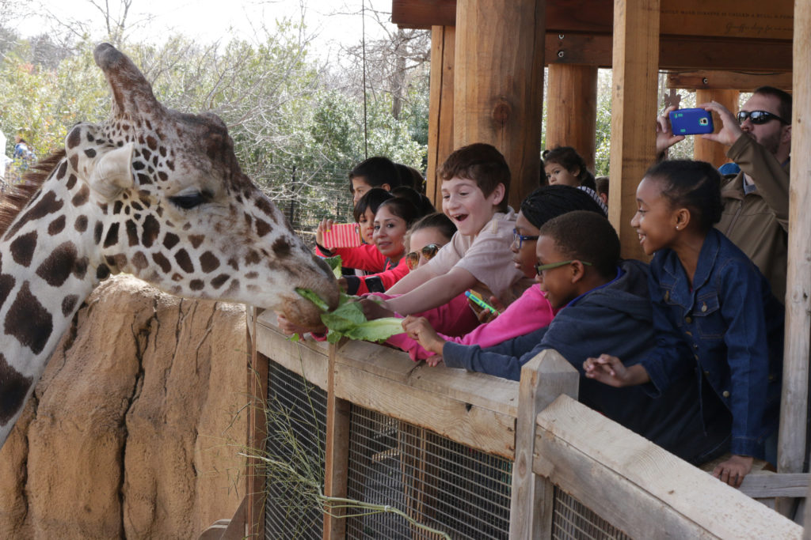

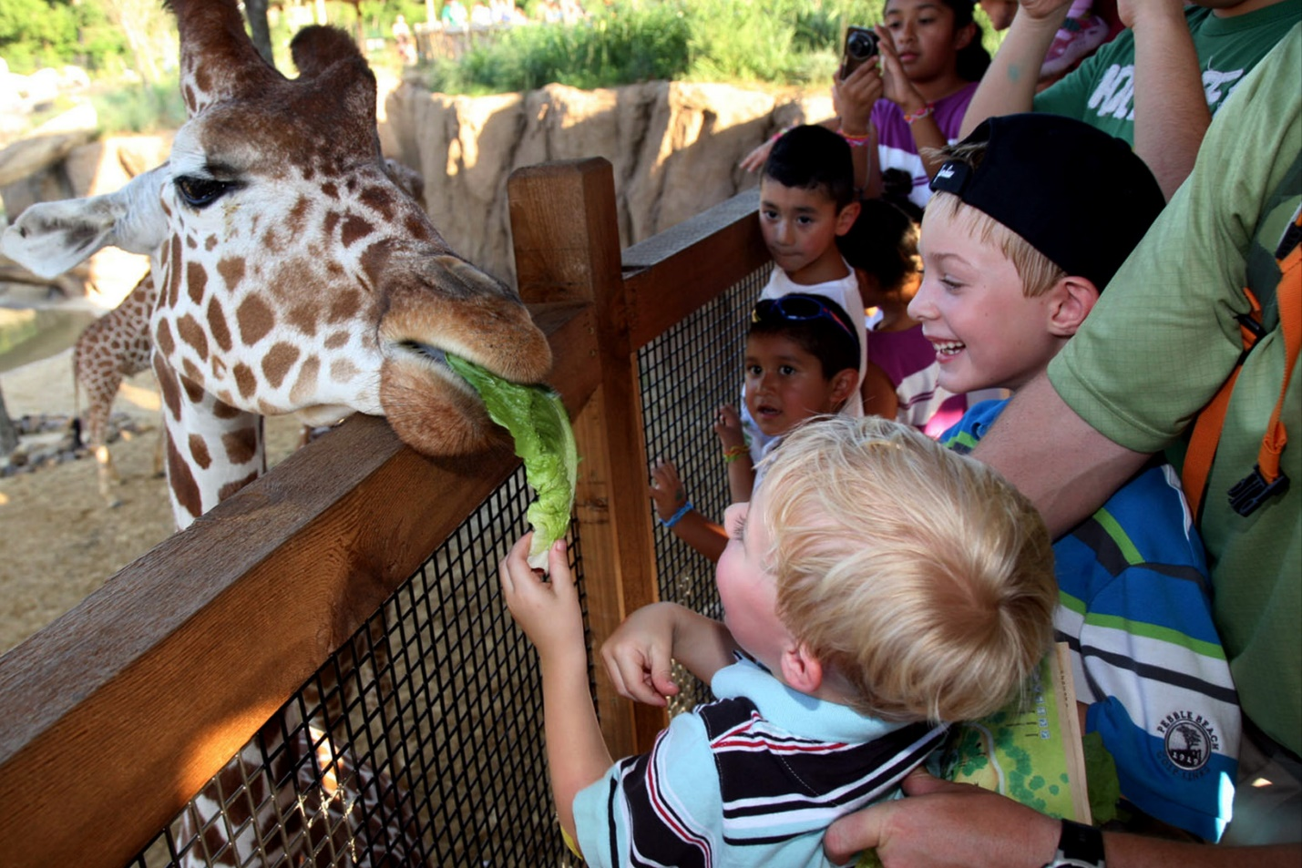

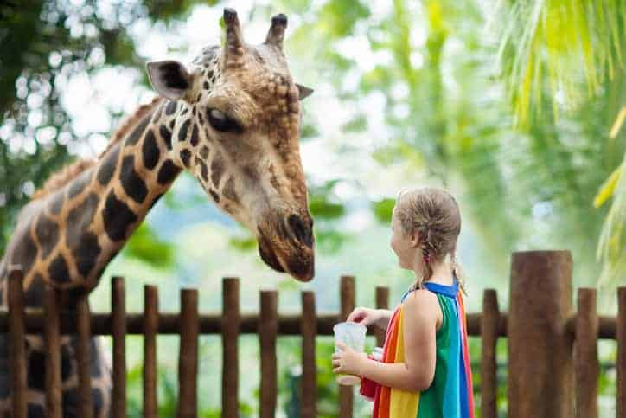

References
https://www.google.com/url?sa=i&url=https%3A%2F%2Fwww.10best.com%2Fdestinations%2Ftexas%2Fdallas%2Foak-cliff%2Fattractions%2Fdallas-zoo%2F&psig=AOvVaw0-rnZoth7ghDGu9u7omDyl&ust=1627902488500000&source=images&cd=vfe&ved=0CAsQjRxqFwoTCMiewtbXj_ICFQAAAAAdAAAAABAD
https://www.google.com/imgres?imgurl=https%3A%2F%2Fmedia-exp1.licdn.com%2Fdms%2Fimage%2FC4D1BAQEjNTcZdBC8OA%2Fcompany-background_10000%2F0%2F1548343809367%3Fe%3D2159024400%26v%3Dbeta%26t%3Dg0eU74XfO1xc5Rsn5Zl74Jlt5l-rm7h7ornAnYX73Mg&imgrefurl=https%3A%2F%2Fwww.linkedin.com%2Fcompany%2Fdallas-zoo&tbnid=RfWV1l1m1UVZAM&vet=12ahUKEwiL89u914_yAhVN3hoKHbhIDbkQMygCegUIARDRAQ..i&docid=0ZXTKJg0WPDDeM&w=1800&h=1200&q=dallas%20zoo&ved=2ahUKEwiL89u914_yAhVN3hoKHbhIDbkQMygCegUIARDRAQ

